Vulcan Activity Tracker
The Athletic Activity Tracker for PennWest California Students.



Design Document
Team Members:
Margo Bonal
John Gerega
Luke Ruffing

Professor:
Dr. Weifeng Chen

Course: Software Engineering Project I
School: Pennsylvania Western University
Instructor Comments/Evaluation

Table of Contents

Abstract 5
Description of the Document 6
Purpose and Use: 6
Ties to the specification document: 6
Intended Audience: 6
Project Block System Diagram 7
Design Details 8
System Modules and Responsibilities 8
System Overview 8
Overview 8
Architectural Diagram 8
Module Cohesion 9
Module Coupling 9
Design Analysis 9
Data Flow 9
Design Organization 9
Detailed Tabular description of Classes and Object 9
Functional Descriptions 9
Input / Output / Return Parameters & Types 9
Modules Used 10
Files Accessed 10
Real-time Requirements 10
Narrative/PDL 10
Decision: Programming language / Reuse / Portability 10
Implementation Timeline 10
Design Testing 11
List of Resources 12
Appendix I: Schematic and Bill of Materials 13
Possible Hosting Service Options: 13
Schematic of Toolset: 13
Appendix II: Team Details 14
Appendix III: Workflow Authentication 15
Appendix IV: Report from Writing Center 16

Abstract
This paper is designed to be read by the software developers of the Vulcan Activity Tracker. It will lay out the development side designs and requirements of this application. This application will allow users to log in using a PennWest email address and a unique password, manually track an exercise they have done, and then store their exercise in a backend database. The developers will use the information in this document to gain insight on their best process to handle the project. The details list the interaction between the frontend and backend elements of the application, as well as the programming languages that will be used to achieve this.

Description of the Document

Purpose and Use:
The purpose of this document is to give software development guidance to the architecture of the software. This document will also show in detail the programming language and functions needed to make sure the application runs smoothly. It will be used by the software developers as a way to ensure the project stays on track without too many disruptions or delays.

Ties to the specification document:
This document extends what the specification document shows and adds components relevant to the software development side. This document will show what programming language will be used and what style of programming architecture will be implemented into the project.

Intended Audience:
This document’s target audience are the software developers and designers as there are many technical terms and phrases within. This document is not meant to be read by the client, but it may be in the best interest of them to have a technically capable third party member to review the document and ensure that it aligns with the client’s requests. Software developers and designers should use this document to better understand the scope of the Vulcan Activity Tracker, including the application’s modules, data flow, variables, functionality, architecture and system requirements.

Project Block System Diagram
The Vulcan Activity Tracker will consist of 2 main software components, Client (Frontend) and Server (Backend) Sides. Client Side will be user interface that is accessible by internet hosting. Server Side will be the driving functionality of the application that will be designed to handle data propagation and database storage. The UI will prepare and send fitness activity data to the Backend Server. The Server will then clean the data and prepare it for database entry. When received by database handling logic, the fitness activity data is then sent into and stored by the MSSQL database.
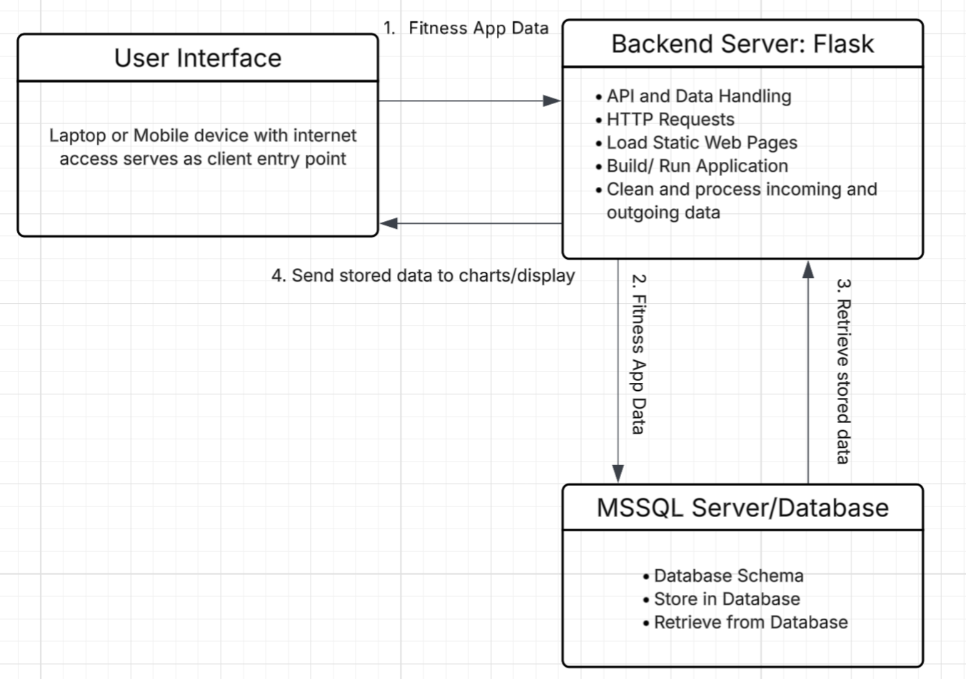
Figure 1: Block Diagram

Design Details

System Modules and Responsibilities
The Vulcan Activity Tracker will be composed of many system modules that hold the responsibility of data transfer, propagation, display, and other driving factors that will bring the project from concept to actuality. Modules will be designed with an object-oriented approach, aiding reusability and time efficiency. All team members are trained on the object-oriented method; however, team meetings will be held to agree on cohesive structure design.

System Overview
The following system overview will represent the design strategy needed to incorporate all fitness and user data for the Vulcan Activity Tracker. The Vulcan Activity Tracker has many pieces of information that it will handle. This includes user demographics for profile registration/passwords and fitness activity information. The application also will store activity environment information of running paths and gym amenities. Data storage will be the most complex but key feature of the Vulcan Activity Tracker. Cleaning and preparing the data for database entry must happen initially. Applying validation checks of data entry fields will aid in eliminating cyberattacks. By implementing a private database designed only for application use, all data can be stored and used without pollution of other external sources.

Overview
The Vulcan Activity Tracker, once completed, will be available for California campus students to access through URL link. This link can be accessed through either laptop, PC, or mobile devices with updated web-browser. Upon entry to the web-based application, a student will be prompted to login with campus email address. This email will be validated with proper pennwest.edu suffix and the student will be asked to make a custom password for entry.
Once verified, a campus student can then access the Vulcan Activity Tracker’s amenities. Users will be able to view their profile, add a new workout, look at past fitness activities, and participate in group activities. Users will additionally be able to view the platform’s leaderboard. All fitness and user data entered will be stored in the database and any calculations performed. Upon session, stored data will also be pulled from storage to fill all graphical features such as tables and graphs. Overall design strategy is proposed for usability, cohesive design, and functional features with the student user in mind.

Architectural Diagram
The following diagram, Figure 2, represents the Architectural Design of the Vulcan Activity Tracker. The diagram follows the users’ access to the application and the appropriate actions that are triggered. A crucial layer of the internet is represented below, since internet access both hosts the application and provides connection between multiple users. The final structure represented below is the Backend/Server. This component will be the most complex factor of development since it handles HTTP requests, port specification, data handling, and database schema configurations.
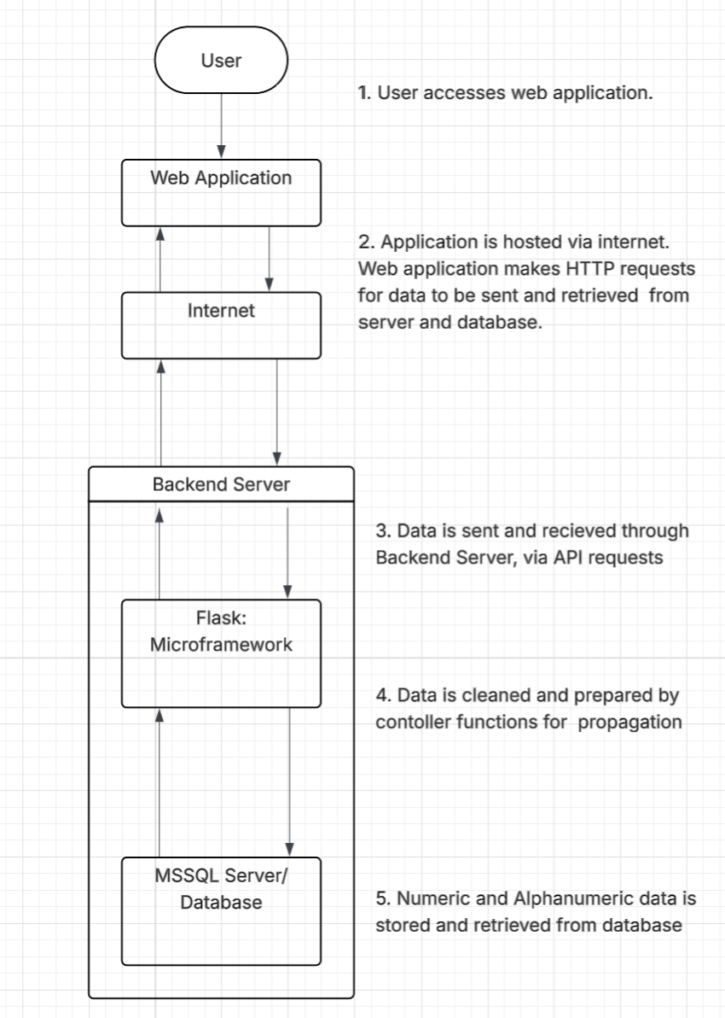
Figure 2: Architectural Diagram

Module Cohesion
Each of the modules in the Vulcan Activity Tracker have a well defined responsibility resulting in high cohesion throughout the system.
- The Login & Authentication Module: This module focuses solely on validating the login credentials of users.
- The Activity Management Module: This module handles only the creation, validation, removal, and retrieval of activities.
- The Group Management Module: This module handles only the management of club/group memberships and roles.
- The Leaderboard Module: This module focuses only on processing and displaying the rankings within different parts of the Vulcan Activity Tracker/
- The Database Module: This module solely manages the storage and retrieval of data items into and out of the database/

Module Coupling
The modules within the Vulcan Activity Tracker have a low coupling to reduce the dependencies modules have on each other.
- The Login & Authentication Module: This module interacts with the Database Module to verify the users login credentials.
- The Activity Management Module: This module interacts with the Database Module to store and retrieve activity data.
- The Group Management Module: This module interacts with the Database Module to store and retrieve group data.
- The Leaderboard Module: This module interacts with the Database Module to store and retrieve leaderboard data
- The Database Module: This module interacts with all the previous modules to send data back and fourth to the database server.

Design Analysis

Data Flow

Design Organization

Detailed Tabular Description of Classes and Object
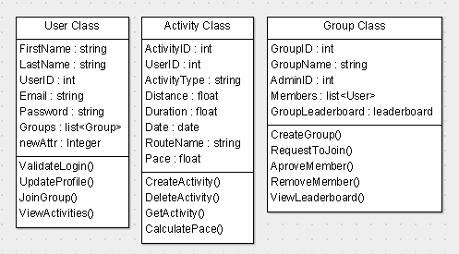
Figure 3: Overview of Classes

The above figure shows an overview of the 3 main classes that the Vulcan Activity Tracker makes use of. Every user on the web application is an instance of the user class. The user can create many instances of both the activity and group classes.
Class name: | User Class
Data members: | FirstName : string  LastName : string  UserID : int  Email : string  Password : string  Groups : list<Groups>
Class member functions: | ValidateLogin()  UpdateProfile()  JoinGroup()  ViewActivities()
Constraints: | Email data member must contain a “@pennwest.edu” email  FirstName and LastName data members cannot be empty.  The Password data member must hold a password that meets minimum security requirements.  The UserID data member must hold a unique ID
Description: | The User Class holds the data needed for each user. It will hold the first name, last name, email and password that the user used to sign up, after sign up each user will be given a User ID which is an integer used to link the user to their activities and groups.

User class member function descriptions:
- ValidateLogin() – Verifies user credentials
- UpdateProfile() – Lets users modify their profile fields
- JoinGroup() – Sends request to join a certain group
- ViewActivities() – Retrieves the users added activities
Class name: | Activity Class
Data members: | ActivityID : int  UserID : int  ActivityType : string  Distance : float  Duration : float  Date : date  RouteName : string  Pace : float
Class member functions: | CreateActivity()  DeleteActivity()  CalculatePace()  GetActivity()
Constraints: | ActivityID data member must hold a unique ID  UserID data member must hold a valid UserID  ActivityType, Distance, Duration, and Date data members must be filled in.  Pace and RouteName data members are optional
Description: | The Activity Class holds the data needed for each activity. As soon as the create activity button is pushed an activity object will be created giving the object a unique activity ID and storing the ID of the user creating the activity. Once created, the activity will ask for the input of activity type, distance, duration, date, route name (Optional), and Pace (Optional). Once all the needed data is added to the activity it will be stored in the database.
Activity class member function descriptions:
- CreateActivity() – Adds a new activity to the database
- DeleteActivity() – Removes an activity from the database
- CalculatePace() – Calculates the pace if distance and duration of an activity exist
- GetActivity() – Retrieves Activities
Class name: | Group Class
Data members: | GroupID : int  GroupName : string  AdminID : int  Members : list<User>  GroupLeaderboard : leaderboard
Class member functions: | CreateGroup()  RequestToJoin()  ApproveMember()  RemoveMember()  ViewLeaderboard()
Constraints: | GroupID data member must hold a unique ID  AdminID data member must hold a valid UserID  GroupName data member must be filled in
Description: | The Group Class holds the data needed to create and manage each group. Once a group is created by a user the group object will receive a unique group ID. The user will then input an appropriate group name and become the group’s administrator. Each group object will also hold the Admin ID (ID of user that created the group), a list of the members, and a group leaderboard that tracks group performance.

Group class member function descriptions:
- CreateGroup() – Creates new group and makes creator the administrator of group
- RequestToJoin() – Sends a request to join to an admin
- ApproveMember() – Admin approved member request
- RemoveMember() – Admin removes user from group
- ViewLeaderboard() – Displays the group leaderboard stats

Functional Descriptions

Input / Output / Return Parameters & Types
Activity Class
CreateActivity():
Input: CreateActivity will take in user data that is placed into a list
Output: The function will output a success or error message depending on whether or not the user enters all required data
Return Parameters: The only values that will be returned will be exceptions thrown during error checking, i.e. missing required data
Types: The user list will contain strings, integers, and Python’s datetime type imported from the datetime library

CalculatePace():
Input: This function will take the pace input and duration input if the activity they are entering requires those fields
Output: The function will calculate the pace of the activity and upload it into the database
Return Parameters: The only values that will be returned will be exceptions thrown during error checking, i.e. missing data
Types: The user input will be a Python time, imported from the datetime library

GetActivity():
Input: User will enter the activity name they are looking for, which will be a string
Output: The function will output the activity the user has searched for
Return Parameters: The only values that will be returned will be exceptions thrown during error checking, i.e. missing data or activity not found in database
Types: The user input will be a string

DeleteActivity():
Input: The function will receive the name of the activity that the user wishes to delete
Output: The function will output a success or error message depending on whether or not the user enters all required data
Return Parameters: The only values that will be returned will be exceptions thrown during error checking, i.e. missing required data
Types: The input will be a string of the activity name they wish to delete

Group Class
CreateGroup(): Creates new group and makes creator the administrator of group
Input: Input will consist of group information, such as name, type of group, whether the group is private, and a designated administrator
Output: The function will output a success or error message depending on whether or not the user enters all required data
Return Parameters: The only values that will be returned will be exceptions thrown during error checking, i.e. missing required data
Type: The input will consist of strings for each field of information required to create a group
RequestToJoin() – Sends a request to join to an admin
Input: There will be a optional input, which will be the user’s reason as to why they would like to join the group. The user will have to enter their username that goes along with the request
Output: A message will be displayed saying the request has been sent for review by an administrator of the group
Return Parameters: The only values that will be returned will be exceptions thrown during sending of the request, which in this case could be a database error or an error checking exception of the user not entering their username.
Type: Optional input will be a string, user’s username will be extracted as a string

ApproveMember() – Admin approved member request
Input: The function will take in the admin’s answer to the request, which will be to approve or to deny access
Output: The function will output a message depending on admin’s answer to the request, if the admin approves the request, the user will be added to the group. If the admin denies the request, a message will be sent to the user denied.
Return Parameters: The values returned will be the messages returned during error exceptions, which could be an error in adding the user to the group
Type: The input will be a flag sent to the program based on the admin’s response to the request
RemoveMember() – Admin removes user from group
Input: Function will receive the username or name of the member to be removed from the group
Output: Message of success will be displayed when the desired member is successfully removed from the group
Return Parameters: Values returned will be messages during error checking, which in this case could be an error in finding the member or removing the member
Type: Desired member’s username will be passed in as a string
ViewLeaderboard() – Displays the group leaderboard stats
Input: User will press a button that will call this function
Output: Leaderboard for only the group will be displayed, with the user being able to filter other aspects of the leaderboard
Return Parameters: The only values that will be returned is messages returned from error checking
Type: Function is triggered by a button pushs
User Class
ValidateLogin() – Verifies user credentials
Input: User will enter an email and password. This email will be checked to see if it contains @pennwest.edu at the end. The program will then run a security check on the credentials
Output: User will either be redirected to the application or will have a message displayed that their credentials are wrong
Return Parameters: Values returned by the function will return a message that user cannot be logged in or that there is a missing field that was detected in error checking
Type: Username and password will be strings
UpdateProfile() – Lets users modify their profile fields
Input: User will go in to their profile section and make their changes that they desire
Output: Message will be displayed that the changes were successful
Return Parameters: Values returned by this function include a success message or a message dealing with the error checking, which could include missing information in a field
Type: User will be modifying strings in their profile
JoinGroup() – Sends request to join a certain group
Input: User presses button to request to join a group, along with optional reason why they would like to join
Output: A message saying the request was successfully sent will be displayed to the user
Return Parameters: Values returned by this function will be messages due to error checking, which in this case could be an error in sending the request to the proper administrator of the group
Type: Optional reason to join the group is a string, request is a button
ViewActivities() – Retrieves the users added activities
Input: User will press the button to retrieve their activity history
Output: A list of the user’s activities will be displayed
Return Parameters: Values returned by this function will be messages produced by error checking, which in this case could be with retrieving the activities from the database
Type: User will push a button to activate this function

Modules Used
The Vulcan Activity Tracker is organized into an architecture that is consistent with Figure 2. At the top is the web application which interacts with the backend server through the internet. Within the backend server the following modules are implemented.
- The Login & Authentication Module: This module validates a users pennwest credentials.
- The Activity Management Module: This module handles gathering and storing activity information
- The Group Management Module: This module handles the management of club/group participation.
- The Leaderboard Module: This module processes and displays rankings within different parts of the Vulcan Activity Tracker
- The Database Module: This module handles the communication between the Vulcan Activity Tracker and its MSSQL database server.

Files Accessed

Real-time Requirements

Narrative/PDL

Decision: Programming language / Reuse / Portability
Our backend code will be written in Python. We chose Python due to its ability to scale and security. Python’s scalability is enhanced by asynchronous runtimes, Just-In-Time compilers, and Container orchestration platforms. While Python cannot match the speed of a raw language like C++, real-world systems care more about throughput and the ability to scale horizontally (Why Enterprises Are Still Choosing Python For Backend Development). Python’s security features include static analyzers, frameworks like Django with built-in defenses against SQL injection, and a provided Open Web Application Security Project (OWASP), which maintains robust Python-specific guidelines and cheat sheets, essentially offering a blueprint for secure coding practices (Why Enterprises Are Still Choosing Python For Backend Development).

Implementation Timeline
The following table represents the timeline of implementation for the Vulcan Activity Tracker. This timeline takes into account initial software design through completion of manual, documentation, and final product presentation. As seen below, January through April is reserved for primary development time. April through May will be used for project validation, revisions, testing, and final product presentation. This document servers as contractual agreement to defined timeline proposal.
Activity | January | February | March | April | May
Component Design
Software Design
Unit Testing
System Integration
System Validation
Operation Manuals
Revisions/ Upgrades
User Demonstration/ Presentation

Design Testing
To ensure the highest quality deliverable, this document was carefully revised. Team discussions were held to unite project scope, actions, and development path. Each team member added both valuable insight and documentation to this Design Document. Multiple drafts were formed, discussed, and revised to produce this final document. Digital communication was key in this process since it was developed primarily remote, however, in-person meetings were held to discuss specifics and hold progress updates.
The same procedure will be implemented during the software development phase of the Vulcan Activity Tracker. During development process, each component and feature will be tested for quality of use, error checking, data validation, and usability. After timeline stages, the project will also be tested for overall design cohesion. The development team will serve as primary testers; however, external testers will be implemented for egoless design opinions. Late-stage revisions and changes will be discussed as group and voted upon. Any design or development disagreement will be further held to an overall vote and gaining advice from professor. Overall, the development team and selected testers will brute force test the Vulcan Activity Tracker to the best of their ability to achieve high quality final product.

List of Resources
Render. (2025). Pricing.
https://render.com/pricing
Why Enterprises Are Still Choosing Python For Backend Development
https://dev.co/python/backend-development

Appendix I: Schematic and Bill of Materials
Cost constraints will be related to software toolsets and subscriptions. Development tools will need to be evaluated and considered with cost analysis. Since most toolsets and libraries will be open-sourced, the primary cost constraint for the Vulcan Activity Tracker will be web application hosting service. Most services only allot certain time periods for free hosting, or certain qualities of service. The best hosting application will be decided through team decisions.

Possible Hosting Service Options:
Render Pricing Sheet:
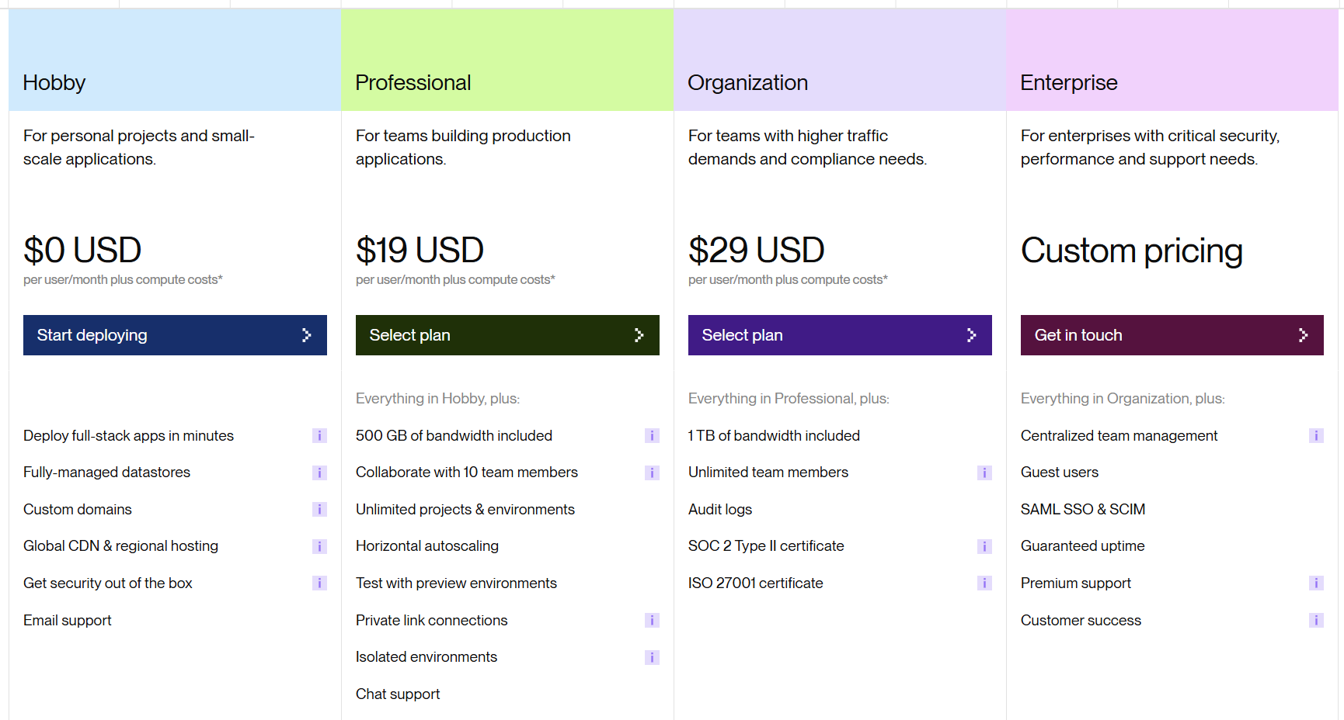
Source: Render (2025)

Schematic of Toolset:
Tool: | Price:
MMSQL Management Studio | Open Source
VS Code | Open Source
Flask Framework | Open Source
HTML/CSS | Open Source
Python | Open Source

Appendix II: Team Details
This design document was developed through the collaboration of all team members. The document was made with the combined efforts of the entire team over the course of the project timeline. While each member contributed across various parts of the document, the primary contributors for each section are listed below:
- Margo Bonal:
- John Gerega:
- Luke Ruffing:
The rest of the major sections of the document were completed collaboratively with all members participating equally in discussions, decision making, and writing. This collaborative approach taken to completing the document allowed the group to refine ideas and reach a consensus before making any big decisions.
In addition to the writing of each section, all team members took part in proof reading and formatting ensuring the creation of a clear, concise and well-organized document. Together the team worked to check for proper grammar, proper citation, and adherence to all formatting guidelines.

Appendix III: Workflow Authentication
I, Margo Bonal, confirm that all work I have contributed to this document has been to the best of my knowledge, completed with integrity and in accordance with the objectives and collaborative standards established by the team. I attest that I will maintain these standards in all future contributions to this project.

Signature:  Date: 12/9/25
I, John Gerega confirm that all work I have contributed to this document has been to the best of my knowledge completed with integrity and in accordance with the objectives and collaborative standards established by the team. I attest that I will maintain these standards in all future contributions to this project.

Signature:  Date: 12/9/25
I, Luke Ruffing, confirm that all work I have contributed to this document has been to the best of my knowledge completed with integrity and in accordance with the objectives and collaborative standards established by the team. I attest that I will maintain these standards in all future contributions to this project.
Signature: Date: 12/9/25

Appendix IV: Report from Writing Center

